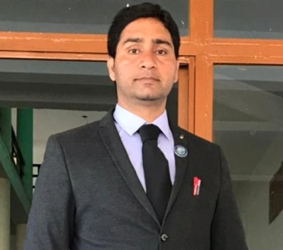

Amit Verma

Assistant professor in Nimbus School of Education

Area

Primary Area: Education

Secondary Area: Humanities,

Contact: 7017930866

Email: amitverma5443@gmail.com

Phone: +91-7017930866

Education

• Master of Education, SDBIT Dehradun (HNBGU)

• Bachelor of Education, Trinity College (HNBGU)

• Master of Art, Bachelor of Art

Teaching

• Political Science

• Contemporary India and Education

• Gender School and Society

Research Area

Indian Polity, Indian Philosophy

Academic Experience

Faculty Member, Nav Chetna School of Education , Dehradun, May 2018 to August 2021.

Faculty Member, Nimbus School of Education, September 2021 onwards.

Professional Experience

Nimbus School of Education

Nav Chetna School of Education